**Challenge Proposal**

**Purpose/Theme**

**Cebuano to English** is Cebuano to English Educational **Game** designed for Filipinos. This is a very fun and challenging way to master Cebuano **to English** translation. The game has a very simple idea and that is to translate a word from Cebuano to English.

### Audience

This game is geared towards families and friends who want to master English, adults and children as young as 3 can play.

### Data Sources

* Set correct answers to localStorage
* local JSON file of images

### Modules

### ceblish.js

### ls.js

### Utilities.js

### Wireframes

### C:\Users\AWE Goldy Jojo\OneDrive\BYU-IDAHO 2020\2020 Courses\Web Backend\WDD330 Web Frontend Development II (3-IP)\wk7\start.JPG C:\Users\AWE Goldy Jojo\OneDrive\BYU-IDAHO 2020\2020 Courses\Web Backend\WDD330 Web Frontend Development II (3-IP)\wk7\wireframe cp.JPG

### C:\Users\AWE Goldy Jojo\OneDrive\BYU-IDAHO 2020\2020 Courses\Web Backend\WDD330 Web Frontend Development II (3-IP)\wk7\restart.JPG

### C:\Users\AWE Goldy Jojo\OneDrive\BYU-IDAHO 2020\2020 Courses\Web Backend\WDD330 Web Frontend Development II (3-IP)\wk7\wireframe tab.JPG

### C:\Users\AWE Goldy Jojo\OneDrive\BYU-IDAHO 2020\2020 Courses\Web Backend\WDD330 Web Frontend Development II (3-IP)\wk7\wireframe comp.JPG

### Style Guide

#### Logos & Icons

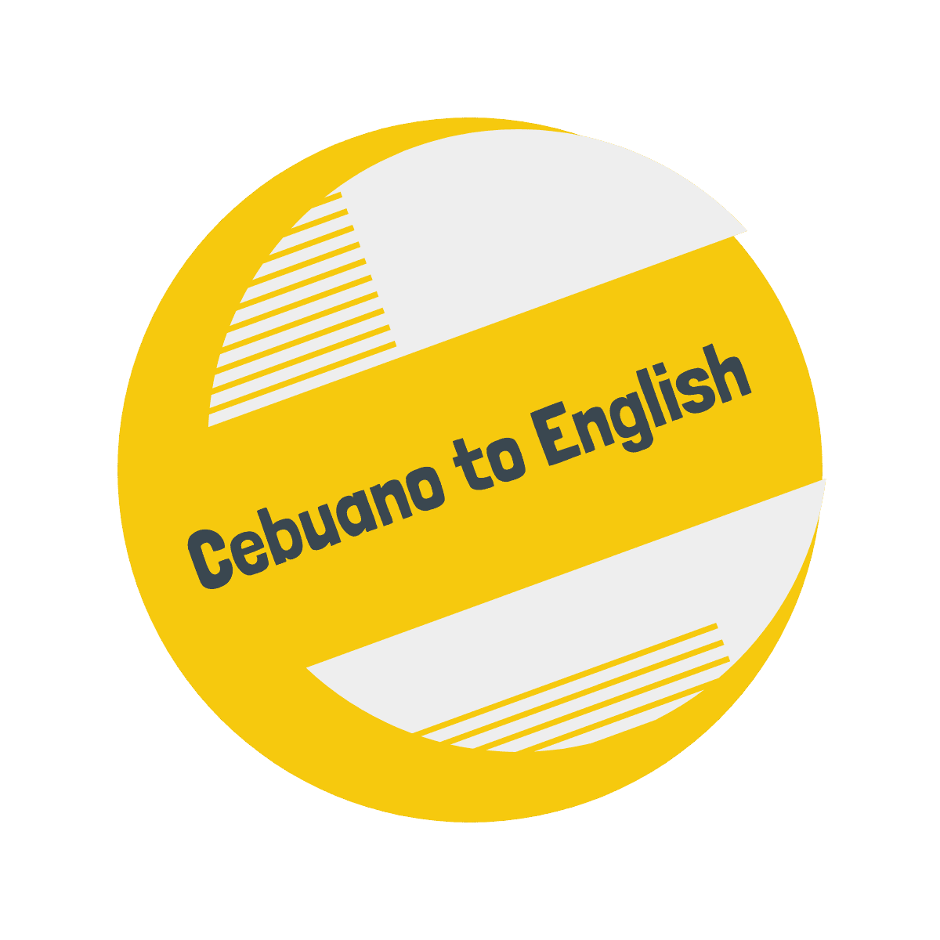

logo_transparent C:\Users\AWE Goldy Jojo\OneDrive\BYU-IDAHO 2020\2020 Courses\Web Backend\WDD330 Web Frontend Development II (3-IP)\wk7\HatchfulExport-All\favicon.png favicon

#### Colors

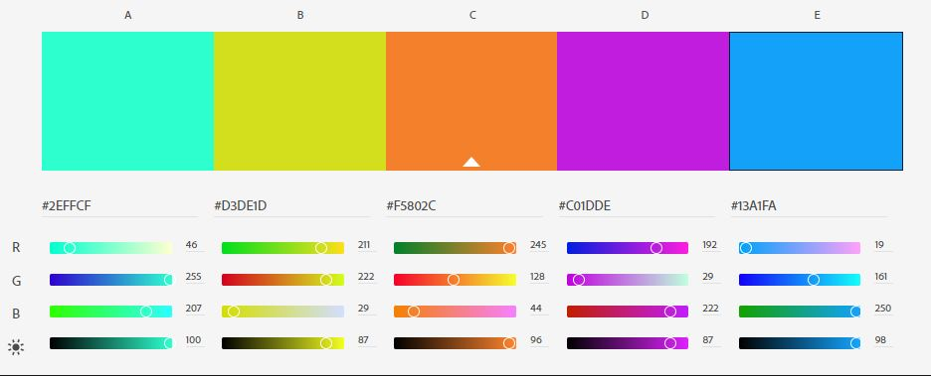

#### Typography

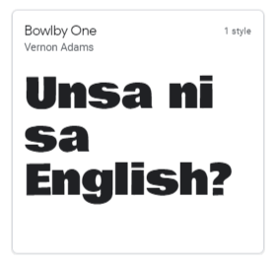

Bowlby One is perfect for big bold headlines and display uses that need a slightly roughened look. Bowlby is a web font, designed to be used freely across the internet by web browsers on desktop computers, laptops, cloud systems and mobile devices. Its forms are a fusion of a handfull of designs scanned from old, early Twentieth Century type specimens.

#### Schedule

##### Week 10

* HTML
* CSS
* Layout
* Header
* Hover, transitions, animations
* Design images to be used

##### Week 11

* Buttons
* Obtain player name for score board
* Play button to start game

##### Week 12

* Calculate score

##### Week 13

* Complete any tasks that proved more difficult than expected
* Stretch: Tutorial
* CSS
* Display score
* Add more images to array and set to localStorage/json